SEMINAR IN ENGLISH: WWII LITERATURE – ENG 410-V

Instructor: Dr. Melissa Dinsman Office Hours: M: 12-2
Email: mdinsman@york.cuny.edu Office: AC-2B10, Phone: 718.262.2525
Semester: Fall 2017 Time / Place: W: 6-8:50 / AC-2A05

Website: https://eng410wwiilit.commons.gc.cuny.edu/

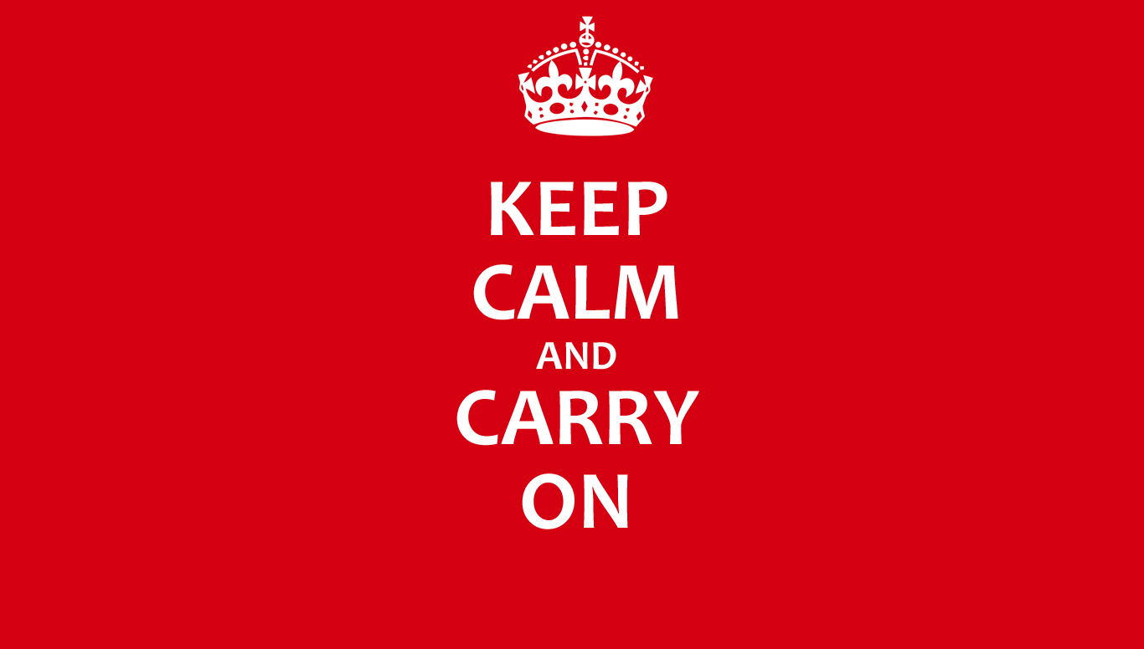

COURSE DESCRIPTION

Course Description: In this course, we will examine one of the most tumultuous times in British history: The Second World War. Britain’s civilian war lasted from 1939-1945 and involved massive Nazi bombing campaigns of British cities, including what is now known as the Blitz (September 1940-Summer 1941) and the later V-1 and V-2 rocket attacks (1944-1945). As a result, the British government and the Ministry of Information (Britain’s propaganda headquarters during the war) labeled the struggle a “People’s War” and worked to 1) boost morale through a cultural solidarity campaign and 2) present a positive image of Britain abroad, specifically to the US, in order to obtain American aid. Britain’s people were immersed in a “total war” in which all structures—social, cultural, industrial—were engaged in mediating wartime propaganda. This propaganda was transmitted through a variety of media, including pamphlets and posters, radio broadcasts, novels, documentaries, and films created on both sides of the Atlantic. Together, we will explore the ways in which culture makers both addressed and challenged the propaganda narratives of World War II in an attempt to understand the lasting impacts they have had on our understanding of the war.

Catalogue Description: 3 hrs. 3 crs. A special topic in English. Preq: WRIT 301, 302, 303 or 304; twenty-four credits in the English major; senior status; and departmental permission. The topic varies with each offering. This course may be repeated for no more than 6 credits if different topics are studied. This is a Writing Intensive course.

LEARNING OBJECTIVES

- Speak and write confidently about the literature and culture of WWII Britain.
- Identify and analyze specific propaganda narratives relating to WWII and how these narratives shaped culture and everyday life.
- Understand and articulate complex insights about primary (text, film, radio, newspaper) and secondary (critical, historical, theoretical) texts.
- Use digital humanities methods to research, create, and document projects as a method to understanding WWII literature and culture.
- Produce a capstone research paper of near-graduate level quality that supports an original thesis and makes independent connections between primary and secondary sources.

REQUIRED TEXTS

- Elizabeth Bowen, The Heat of the Day, Anchor Books (9780385721288)
- Daphne du Maurier, Rebecca, Harper (9780380730407)
- Henry Green, Caught, New York Review Books (9781681370125)
- Graeme Greene, The Ministry of Fear, Penguin Classics (9780143039112)
- Patrick Hamilton, Slaves of Solitude, New York Review Books (9781590172209)
- Jan Struther, Mrs. Miniver, Harcourt Brace (9780156631402)
- Evelyn Waugh, Put Out More Flags, Back Bay Books (9780316216425)
- Virginia Woolf, Three Guineas, Harcourt Brace (9780156901772)
* Additional readings and film/broadcast links can be found on our CUNY Commons (CC) site.

COURSE REQUIREMENTS

- 2 Critical Response Papers (2-3 pages each) 20%
- Cultural Research Blogs 15%
- Media Project and Presentation 20%
- Final 35%
  - Paper (13-15 pages) (30%)
  - Proposal and Bibliography (5%)
- Class Participation 10%

Critical Response Papers: There are two short (2-3 page) responses for this course that will ask you to form an argument about a select text. These papers will help you form ideas and critical engagements (e.g. close readings of primary and secondary texts) with the course materials in preparation for a longer sustained research paper. We will discuss the exact format of these in class.

Cultural Research Blogs: There will be three cultural research projects (worth 50 points each) that will require you to either research or recreate an aspect of British culture and document it on the blog. These cultural blog posts will be a minimum of 500-words and should include images, videos, and/or links. You will receive the parameters and due date for each of these blog posts well in advance.

Group Project: Toward the end of term you will showcase your understanding of WWII propaganda methods through a creative digital work. The sky is the limit for this project. You can create a short documentary, a series of propaganda posters, a radio broadcast, a short story, etc. We will discuss technological options in class. Your grade for this project will be split between the final product and your group presentation.

Final: Your capstone paper will be composed of a 13-15 page research paper (with a research proposal and bibliography being due mid-semester). This paper will require you to use at least 12 secondary sources. You will be able to pull ideas and select critical readings from your shorter papers, if they pertain to your final topic.

Class Participation: Our discussions depend on your participation for their success. Your participation in peer-review writing workshops, discussion, group activities, and in-class assignments will be assessed for your final grade. Please be on time and ready to participate in all activities. You should also always have the assigned book in class with you. Failure to have your text in class may result in you being marked absent.

COURSE POLICIES

Attendance: Excessive absences, excessive tardiness, and extra-long bathroom breaks will all adversely affect your grade. If you have not arrived to class by the time I have called roll, you will be marked as late and this will count as 1/3 of an absence. Sleeping in class or composing or reading text messages will adversely affect your grade. You can miss up to two (2) classes with no penalty. Use these wisely. Missing more than two (2) classes will automatically lower your grade by 10% and more than four (4) absences will result in an F. You are expected to be present and an active participator in class discussion. If you have an exceptional reason for being absent, such as a medical emergency (note, this does not mean a cold), please come speak with me privately.

Assignments: All materials are due in-class on the assigned day. Should you be absent on the day an assignment is due, it must be placed in my mailbox or emailed to me before the beginning of class on that day. Late assignments will be accepted; however, the grade will drop one letter for every day late. If you are late to class and turn the assignment in after I call roll, your paper is late and will receive a 1/3 of a letter grade late penalty. All assignments are to be stapled, double-spaced, in Times New Roman 12pt font, and have 1” margins. Please keep in mind the page limit for each assignment. Going extremely over or under the limit will affect your grade.

Books: You must have a hard copy of each book in class. No e-books or reading on screens will be allowed. You must also have the editions listed in the syllabus so that class discussion runs smoothly. If you do not have your book in class, I will make a note of it and you will be docked for participation.

Cell Phones / Computer Use: Please turn off your phone while in class. Texting, checking messages, and vibrating phones are all very distracting in a small classroom. I understand that computers may be your preferred mode of note-taking: if you choose to bring a computer into the classroom, please use common sense (no email, chat, IM, The New York Times, etc.). If computers are abused in the classroom, I will revise this policy to prohibit their use.

Academic Integrity: Plagiarism and cheating are serious offenses that are easy to detect and will not be tolerated. Be sure to document your sources correctly when using someone else’s words or ideas. Failure to do so will result in an “F” for the assignment and possibly the course. If you aren’t certain if something is plagiarism or how to cite a source, please ask me. York College’s policies and procedures concerning academic integrity can be found here:
https://www.york.cuny.edu/academics/academic-affairs/academic-integrity/policy/york-college-policy-and-procedures-on-academic-integrity

YORK COLLEGE RESOURCES:

York College Library: http://york.cuny.edu/library

York College Computer Labs: http://york.cuny.edu/it/acet/computer-labs

York College Writing Center: http://york.cuny.edu/student/writing-center

ESL Tutoring Center: 718-262-2831

Students with Disabilities: http://york.cuny.edu/student-development/star

Writing Center (1C18): Tutors in the center are available to assist you with developing your writing and your writing skills. You are encouraged to visit the Writing Center early in the semester. Don’t wait until a paper is due! The Writing Center offers scheduled tutoring, which allows you to meet with the same tutor each week. Course textbooks and handbooks are also available for use in the Center. For more information, stop by or call the Center (ext. 2494).

COURSE SCHEDULE

This schedule should not be considered carved in stone. Based on the pace and the needs of the class, adjustments will be made. You will be given knowledge of any major changes to the schedule well in advance. NOTE: (CC) means you need to visit our CUNY Commons site.

Week 1: Introduction
W (8/30): Read: Cull’s Selling War, chapter 4
Film: Jennings’ London Can Take It (in-class)

SECTION 1: PREPARING FOR WAR

Week 2: Patriarchy and Fascism
W (9/6): Read: du Maurier’s Rebecca (chs. 1-15) | Woolf’s Three Guineas (ch. 1)

Week 3: The End of Appeasement
W (9/13): Read: du Maurier’s Rebecca (chs. 16-end) | Woolf’s Three Guineas (ch. 2) | Light’s introduction to Forever England (CC)

Week 4:

W (9/20): *** No Class***

Week 5: Women, Middlebrow, and the War
W (9/27): Read: Struther’s Mrs. Miniver | Woolf’s Three Guineas (ch. 3) | Woolf’s “Middlebrow” (CC) | Ministry of Food recipes (CC)
Listen: Chamberlain’s “Declaration of War” (CC)

Due: Food and Rationing Blog (CC)

SECTION 2: EXPERIENCING THE BLITZ

Week 6: The Phony War
W (10/4): Read: Waugh’s Put Out More Flags | Excerpts from JB Priestley’s radio broadcasts Britain Speaks (CC) | Bowen’s “Preface” and “In the Square” from Ivy Gripped the Steps (CC)
Response 1: Peer-Review Writing Workshop

Week 7: Selling the War: Understanding Adaptation
W (10/11): Read: Koppes and Black, Hollywood Goes to War, pages 222-234 (CC) | Film Art: An Introduction, pp. 97-99 (CC) | McFarlane, Novel to Film excerpt (CC)
Film: Hitchcock’s Rebecca (CC) | Wyler’s Mrs. Miniver (CC)

Due: Response 1

Week 8: Documenting the War
W (10/18): Read: Green’s Caught | Woolf’s “Thoughts on Peace in an Air-Raid” (CC) | Tambimuttu’s “Out of this War,” Section III, pp. 13-14 (CC)
Film: Jennings’ Fires Were Started (CC)
Listen: Edward R. Murrow broadcasts (in-class)

Week 9: Uncanny Fiction
W (10/25): Read: Greene’s The Ministry of Fear | Bowen’s “The Demon Lover” (CC) | Victoria Stewart’s “The Auditory Uncanny in Wartime London” (CC)
Extra Credit: Watch Lang’s The Ministry of Fear and write response.

Week 10: The Enemy Within: Fifth Columnists
W (11/1): Read/Listen: Churchill Speeches (audio) | Posters from the National Archives (CC)
Film: Hitchcock’s Foreign Correspondent (CC) | French’s Unpublished Story (in-class screening)

Due: Poster Blog (CC)

Due: Research Proposal and Bibliography

SECTION 3: REMEMBERING THE WAR

Week 11: Love and Bombs
W (11/8): Read: Bowen’s The Heat of the Day (chs. 1-9) | Mass Observation, excerpts from The Pub and the People, pp. 255-269 (CC)

Response 2: Peer-Review Writing Workshop

Week 12: The V1 and V2 Rockets
W (11/15): Read: Bowen’s The Heat of the Day (chs. 10-17) | Rau, “The Common Frontier: Fictions of Alterity in Elizabeth Bowen’s The Heat of the Day and Graham Green’s The Ministry of Fear” (CC)

Group project meetings in class

Due: Response 2 | Optional Draft of Research Paper

Week 13: Meetings
W (11/22): Instructor-Student Paper Conferences

Week 14: Letting Loose: Sex, Alcohol, and Pub Life
W (11/29): Read: Hamilton’s The Slaves of Solitude | Mass Observation, excerpts from The Pub and the People, pp. 1-51 (CC)

Due: Popular Music Blog (CC)

Week 15: Wrap Up
W (12/6): Media Project Presentation and Party

Research Paper due in lieu of Final Exam: TBD during Exam Week.

